Comparing CNN vs ANN
1. Introduction to CNN and ANN Comparison
- differences between a Convolutional Neural Network (CNN) and an Artificial Neural Network (ANN).
- Understanding this comparison is crucial for subsequent videos, especially for grasping how backpropagation works in CNNs.
- Previous discussions highlighted why CNNs are used for image processing and the problems ANNs face with image data. These three problems are:
  - High Computational Cost: Performing image classification tasks with ANNs can be very expensive computationally.
  - Overfitting: ANNs are more prone to overfitting when dealing with images.
  - Loss of Important Features: When a 2D image is flattened into a 1D vector for ANN input, important spatial arrangements of pixels are lost.
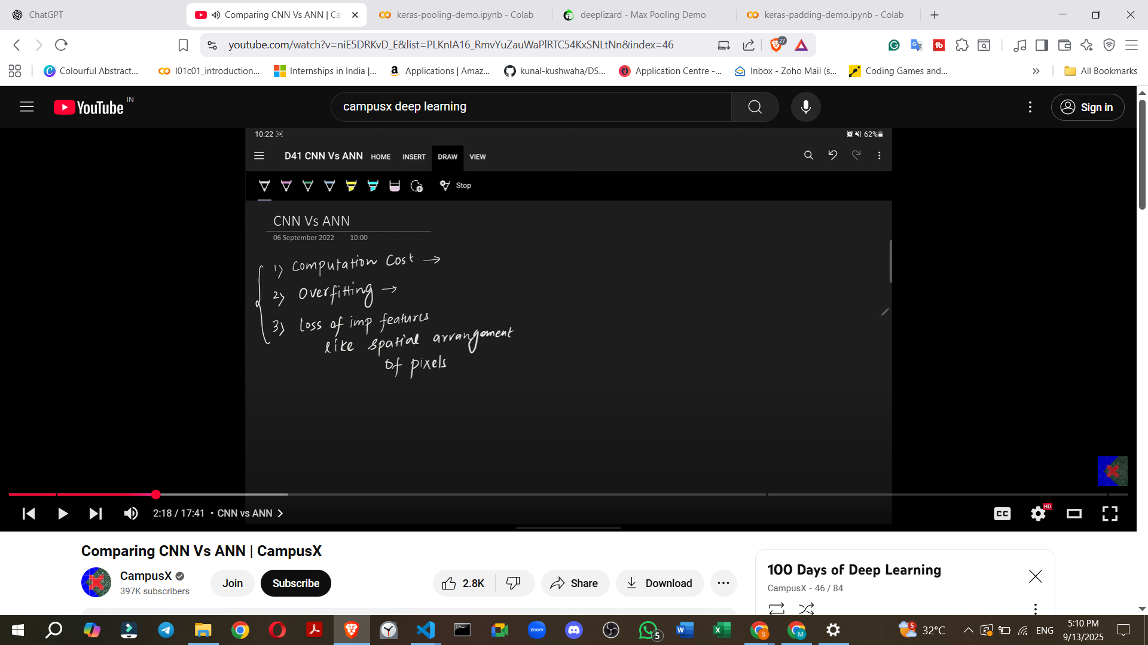
2. How ANN and CNN Process Image Data (Example: MNIST Dataset)
- The video illustrates how both ANNs and CNNs handle image data, using the MNIST dataset (a collection of digit images) as an example for image classification.
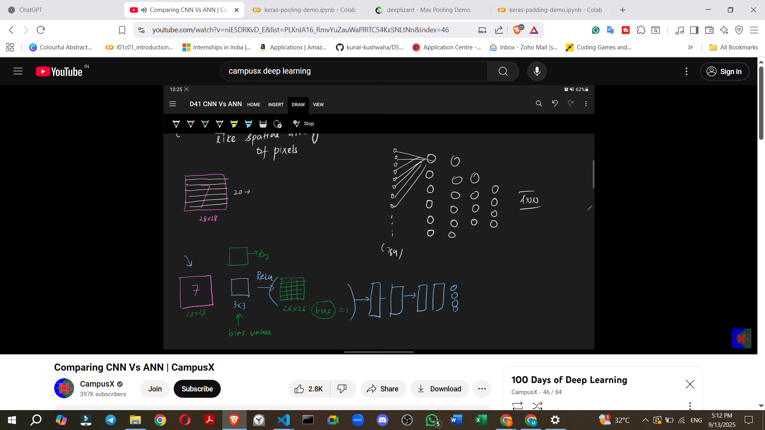
  - ANN's Approach for Image Classification:
    - A 28x28 image is flattened into a 1D vector, resulting in 784 input values (28 * 28 = 784).
    - These inputs are fed into the input layer, followed by fully connected hidden layers.
    - Finally, there's an output layer, typically a Softmax layer.
  - CNN's Approach for Image Classification:
    - CNNs use the image in its original 2D form.
    - Filters (e.g., 3x3) are applied to the image.
    - This process generates a feature map (e.g., a 26x26 map from a 28x28 input using a 3x3 filter).
    - A ReLU activation function is applied to the feature map.
    - A pooling layer (e.g., max pooling) is then used.
    - The output is then flattened.
    - The flattened output is sent to a fully connected layer.
    - Finally, there's a Softmax layer for the output.
3. Similarities between ANN Nodes and CNN Filters
- A key point of the class is that the nodes in an ANN and the filters in a CNN operate in a "similar" way.
  - How an ANN Node Operates:
    - Inputs (x1, x2, x3, etc.) are multiplied by their respective weights (w1, w2, w3, etc.).
    - These products are summed up (dot product).
    - A bias value is added.
    - The result is passed through an activation function (e.g., ReLU).
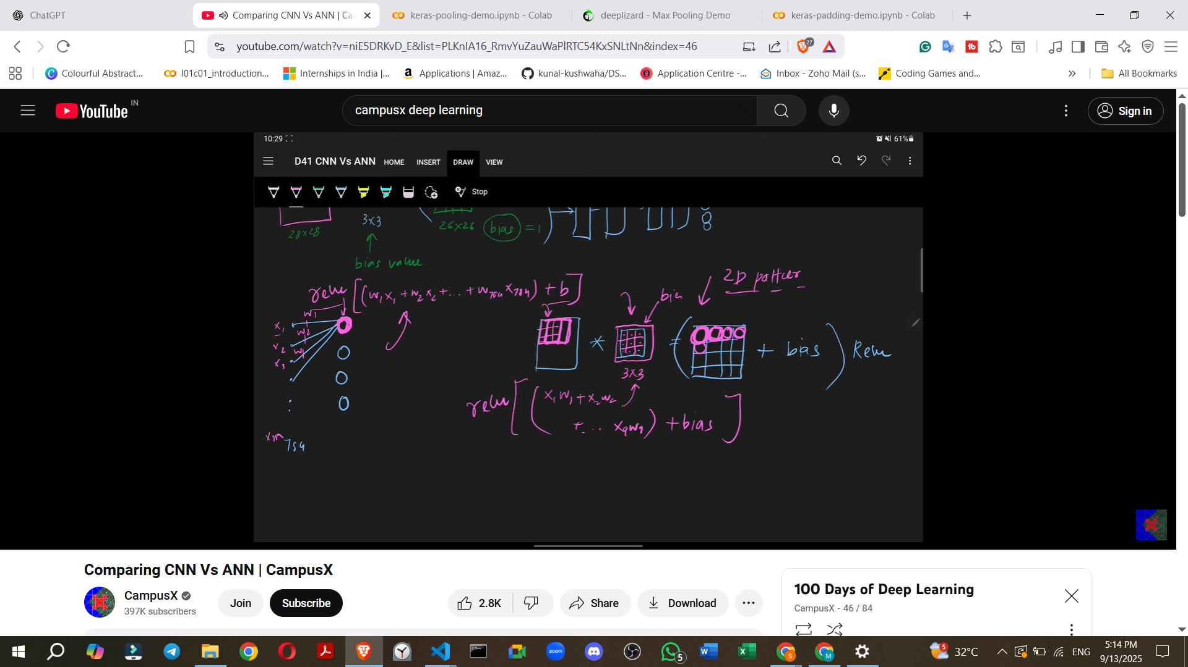
  - How a CNN Filter Operates:
    - During convolution, a filter (which contains weights) is applied to a window of input pixels.
    - For example, a 3x3 filter takes 9 pixel values from the input and multiplies them by its 9 internal weights.
    - These products are summed (dot product).
    - The filter's specific bias value is added.
    - This sum is then passed through an activation function (e.g., ReLU).
    - This entire process is repeated as the filter slides across the image to generate the feature map.
- Underlying Principle: Both ANNs and CNNs perform a dot product, add a bias, and apply an activation function. This fundamental principle is the same.
- Key Difference in Application: While the principle is similar, ANNs process all inputs at once, whereas CNNs work on "chunks" or "windows" of the input, moving across the image. This design allows CNNs to capture the 2D spatial arrangement of pixels.
- Adding a new feature map in a CNN is analogous to adding a new node in an ANN, complete with its own trainable bias and weights.
4. Differences between ANN and CNN: Focus on Trainable Parameters
- The class then shifts to discussing the differences, primarily focusing on how trainable parameters are handled in each architecture.
  - Question/Example 1: CNN Trainable Parameters
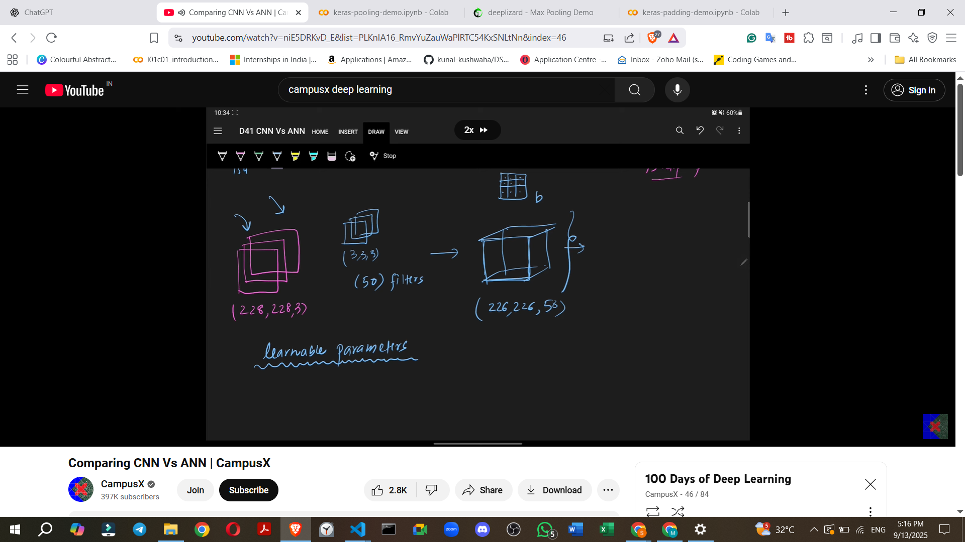
    - Scenario: An RGB image of size 28x28x3 is used. 50 filters are employed, each with a size of 3x3x3.
    - Task: Calculate the number of learnable/trainable parameters in this CNN.
    - The speaker initially states that the correct answer is 14110.
    - Calculation Walkthrough (as presented by the speaker using 50 filters):
      - Weights per filter: 3 (height) * 3 (width) * 3 (channels) = 27 weights.
      - Total weights for 50 filters: 27 weights/filter * 50 filters = 1350 weights.
      - Each filter has its own bias: 50 biases (one per filter).
      - Total learnable parameters: 1350 weights + 50 biases = 1400.
      - Note: There is a numerical discrepancy between the stated correct answer (14110) and the calculated sum (1400) presented in the source.
  - Question/Example 2: CNN Trainable Parameters with a Larger Image
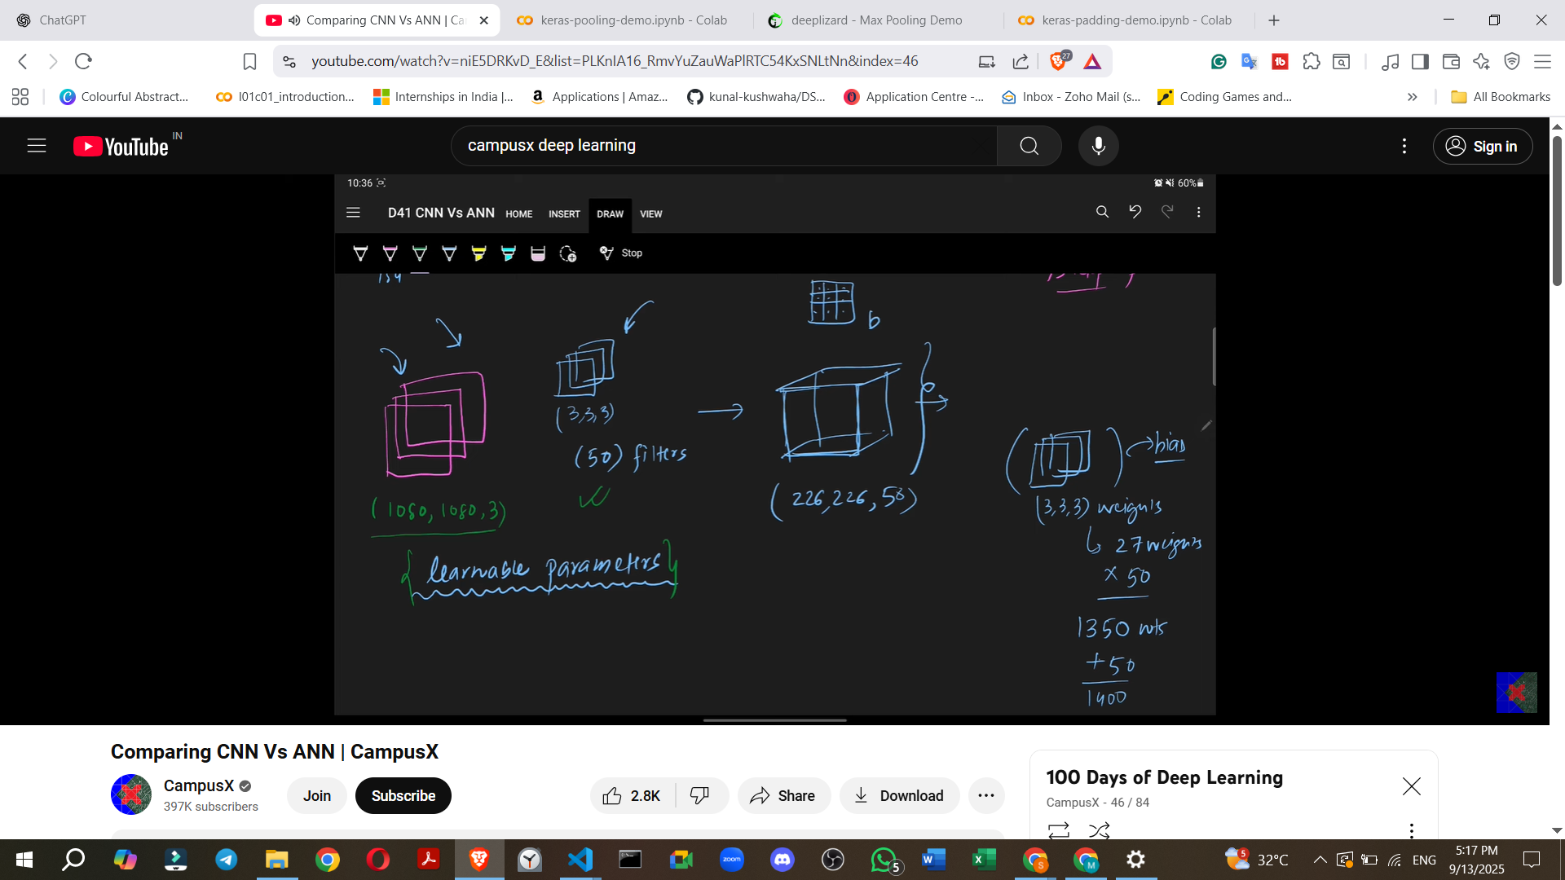
    - Scenario: The image size is significantly increased to 1080x1080x3. The filters remain the same (3x3x3, 50 filters).
    - Task: How many learnable parameters will there be now?
    - Answer: The number of learnable parameters remains 1400 (unchanged).
    - Key Insight: In CNNs, the number of trainable parameters does not depend on the input image size. It only depends on the filter size and the number of filters used. This is a significant advantage of CNNs.
  - Comparison with ANN regarding Trainable Parameters and Computational Cost:
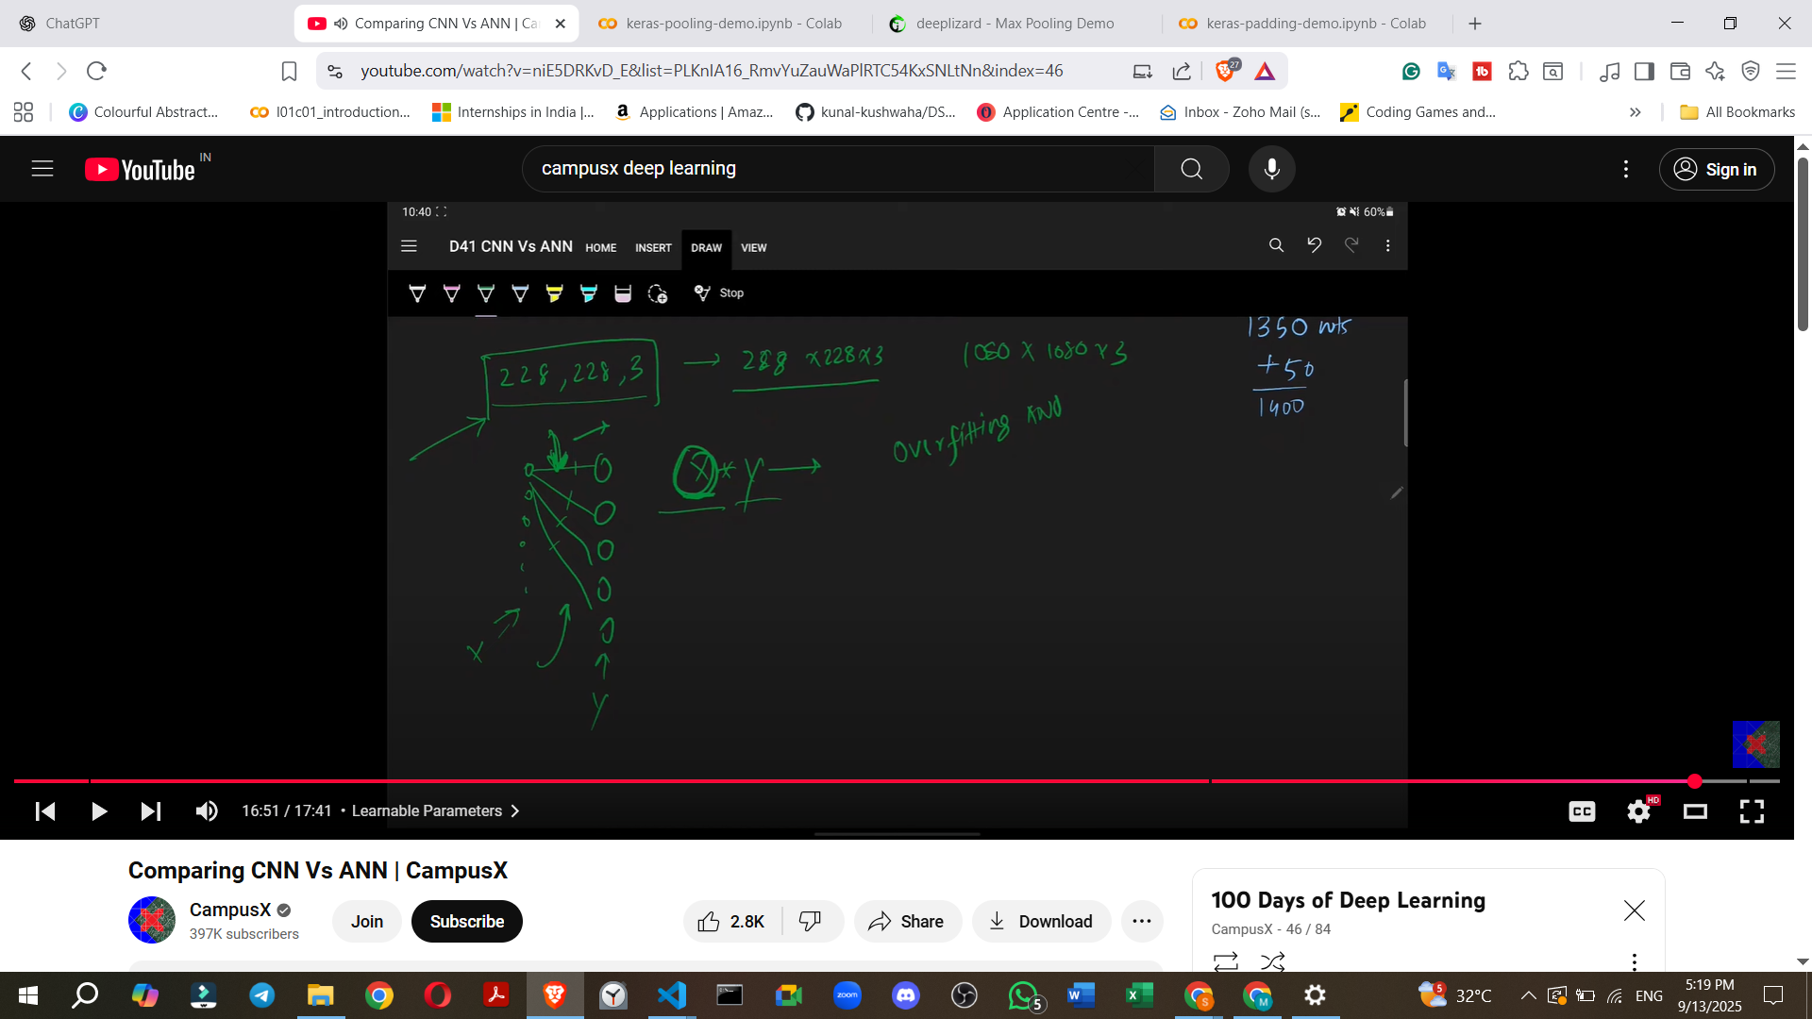
    - ANN Disadvantage: If an input image size increases (e.g., from 28x28x3 to 1080x1080x3), the number of input nodes in an ANN would increase dramatically. This leads to a proportional increase in weights between the input layer and the first hidden layer (calculated as input units * hidden units).
    - For large images, this means ANNs will have millions of weights, resulting in slow training, high computational costs, and an increased chance of overfitting.
    - CNN Advantage: The architecture of CNNs ensures that the number of weights remains constant regardless of the input image size, leading to lower computational cost and reduced overfitting risk.
- Recap of ANN Problems addressed by CNNs:
  - Computational Cost: CNNs offer a more computationally efficient solution for image tasks.
  - Overfitting: The design of CNNs helps mitigate the risk of overfitting.
  - Loss of Spatial Information: CNNs inherently capture the 2D spatial arrangement of pixels through their sliding window mechanism, overcoming the loss of information due to flattening in ANNs.
5. Conclusion
- This understanding of CNN and ANN similarities and differences is vital for the upcoming discussions, especially on backpropagation in CNNs, which will cover how a CNN is trained.

